**Setup**

use Python 3.9.13

install packages using "python -m pip install -r requirements.txt"

run the application using "python -m streamlit run main.py"

**User Manual**

**Home**

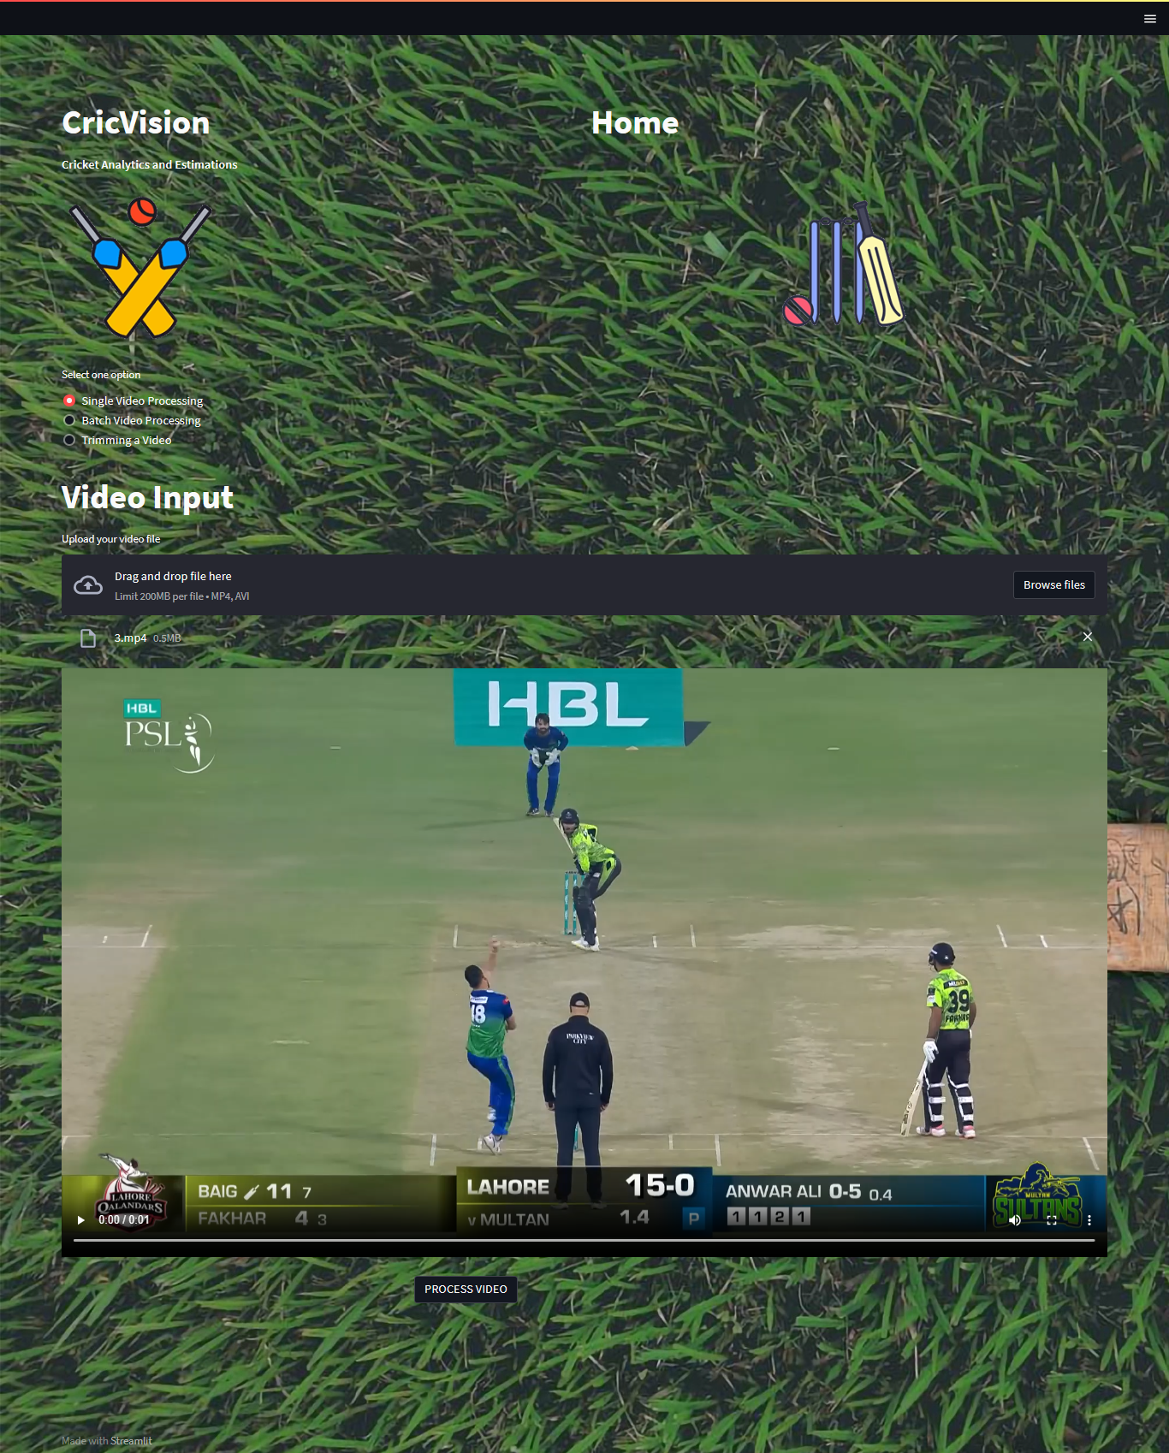

1. The user selects one option from the radio buttons.
   1. Single Video Processing
   2. Batch Video Processing
   3. Video Trimming
2. the user than uses browse video to select videos or video's from explorer
3. The user than clicks on process video

**Single Video Processing**

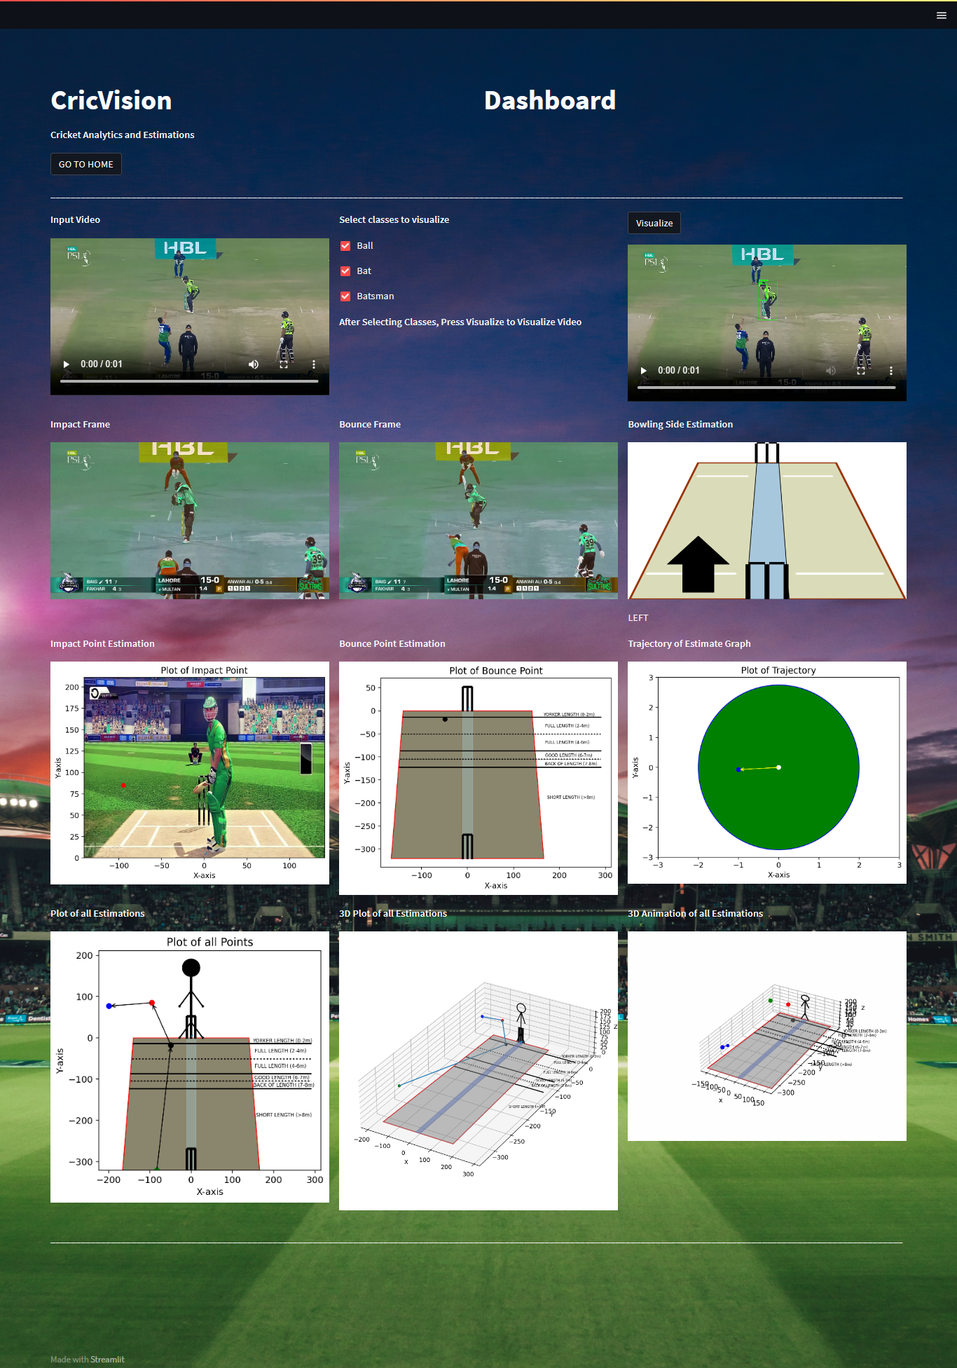

* If the user has selected single video processing, than he processes a single video
* In The top left corner, he can view the original video
* The radio button represents the classes he can visualize within the video
* Clicking on the visualize button at the top right will cause a new video to be generated with the detections visualized based on the selection of classes.
* The Visualizations are at the bottom and are labelled appropriately.

**Batch Processing**

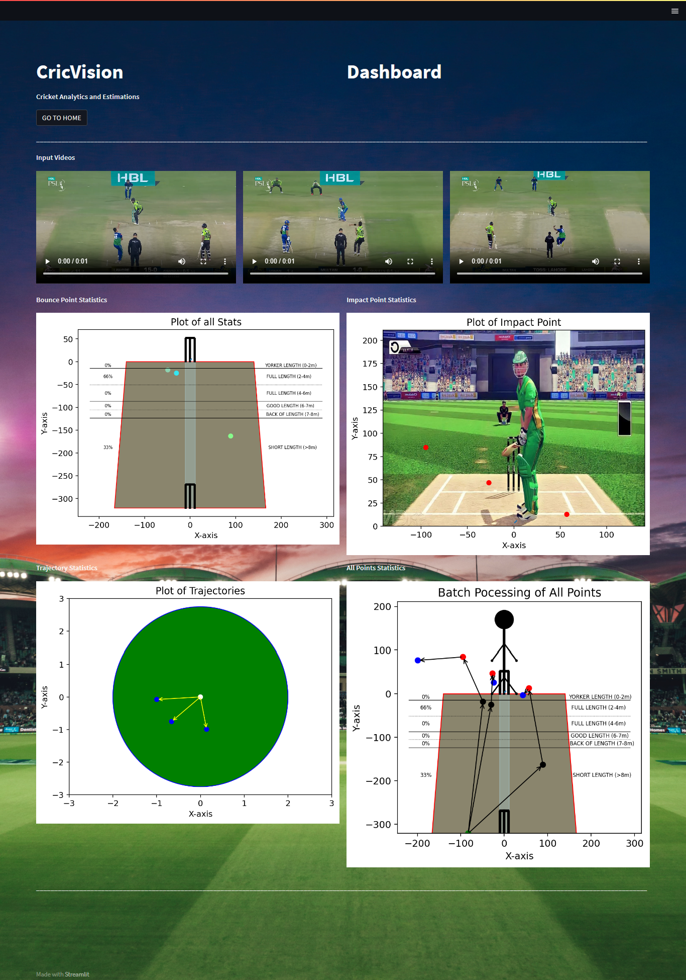

Batch processing processes multiple videos and generates there cumulative graphs

**Video Trimming**

In video trimming a longer video is selected. The module automatically trims the video and generates a folder called output_folder at the root directory